Database Programming with SQL

12-2: Updating Column Values and Deleting Rows

Practice Activities

Objectives

* Construct and execute an UPDATE statement
* Construct and execute a DELETE statement
* Construct and execute a query that uses a subquery to update and delete data from a table
* Construct and execute a query that uses a correlated subquery to update and delete from a
* table
* Explain how foreign-key and primary-key integrity constraints affect UPDATE and DELETE
* statements
* Explain the purpose of the FOR UPDATE Clause in a SELECT statement

Vocabulary

|  |  |
| --- | --- |
| update | Modifies existing rows in a table |
| Correlated subquery update | retrieves information from one table & uses the information to update another table |
| Integrity constraints | Ensures that the data adheres to a predefined set of rules |
| Correlated subquery delete | deletes information on a linked table based on what was deleted  on the other table |
| Delete | Removes existing rows from a table |

Try It / Solve It

NOTE: Copy tables in this section do not exist

If any change is not possible, give an explanation as to why it is not possible.

1. Monique Tuttle, the manager of Global Fast Foods, sent a memo requesting an immediate change

in prices. The price for a strawberry shake will be raised from $3.59 to $3.75, and the price for

fries will increase to $1.20. Make these changes to the copy_f_food_items table.

create table copy_f_food_items

as (select * from f_food_items)

update copy_f_food_items

set Price = 3.75

where description = 'Strawberry Shake'

update copy_f_food_items

set Price = 1.20

where description = 'Fries'

2. Bob Miller and Sue Doe have been outstanding employees at Global Fast Foods. Management

has decided to reward them by increasing their overtime pay. Bob Miller will receive an additional

$0.75 per hour and Sue Doe will receive an additional $0.85 per hour. Update the copy_f_staffs

table to show these new values. (Note: Bob Miller currently doesn’t get overtime pay. What

function do you need to use to convert a null value to 0?)

CREATE TABLE copy_f_staffs

AS ( SELECT * FROM f_staffs)

UPDATE copy_f_staffs SET overtime_rate = NVL(overtime_rate, 0) + 0.75

WHERE first_name = 'Bob' and last_name = 'Miller'

UPDATE copy_f_staffs SET overtime_rate = NVL(overtime_rate, 0) + 0.85

WHERE first_name = 'Sue' and last_name = 'Doe';

3. Add the orders shown to the Global Fast Foods copy_f_orders table:

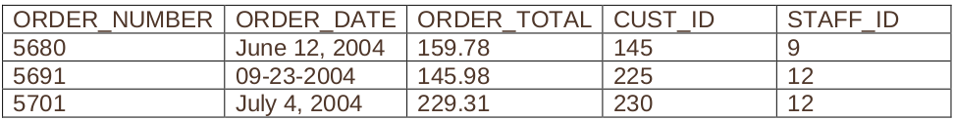

create table copy_f_orders as (select * from f_orders)

INSERT INTO copy_f_orders(order_number,order_date,order_total,cust_id,staff_id)

VALUES(5680,TO_DATE('June 12, 2004','fmMonth dd, yyyy'),159.78,145,9);

INSERT INTO copy_f_orders(order_number,order_date,order_total,cust_id,staff_id)

VALUES(5691,TO_DATE('09-23-2004','mm-dd-yyyy'),145.98,225,12);

INSERT INTO copy_f_orders(order_number,order_date,order_total,cust_id,staff_id)

VALUES(5701,TO_DATE('July 4, 2004','fmMonth dd, yyyy'),229.31,230,12);

4. Add the new customers shown below to the copy_f_customers table. You may already have

added Katie Hernandez. Will you be able to add all these records successfully?

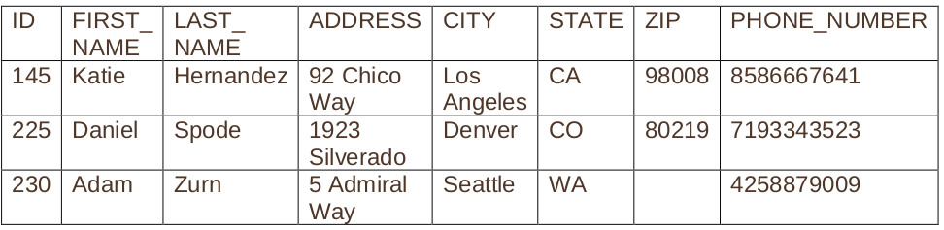

create table copy_f_customers as (select * from f_customers)

INSERT INTO copy_f_customers(id,first_name,last_name,address,city,state,zip,phone_number)

VALUES(145,'Katie','Hernandez','92 Chico Way','Los Angeles','CA',98008,'8586667641');

INSERT INTO copy_f_customers(id,first_name,last_name,address,city,state,zip,phone_number)

VALUES(225,'Daniel','Spode','1923 Silverado','Denver','CO',80219,'7193343523');

INSERT INTO copy_f_customers(id,first_name,last_name,address,city,state,zip,phone_number)

VALUES(230,'Adam','Zurn','5 Admiral Way','Seattle','WA',NULL,'4258879009');

--Asta scoate o eroare, pt ca zip ii non-null

5. Sue Doe has been an outstanding Global Foods staff member and has been given a salary raise.

She will now be paid the same as Bob Miller. Update her record in copy_f_staffs.

UPDATE copy_f_staffs SET salary = (SELECT salary FROM copy_f_staffs WHERE LOWER(first_name || ' ' || last_name) = 'bob miller')

WHERE LOWER(first_name || ' ' || last_name) = 'sue doe';

6. Global Fast Foods is expanding their staff. The manager, Monique Tuttle, has hired Kai Kim. Not

all information is available at this time, but add the information shown here.

insert into copy_f_staffs values

(25, 'Kai', 'Kim', '3-Nov-1988', 6.75, NULL, NULL, 'Order Taker', NULL, NULL, NULL)

7. Now that all the information is available for Kai Kim, update his Global Fast Foods record to

include the following: Kai will have the same manager as Sue Doe. He does not qualify for

overtime. Leave the values for training, manager budget, and manager target as null.

update copy_f_staffs

set manager_id = (select manager_id from copy_f_staffs

where first_name = 'Sue' and last_name = 'Doe')

where first_name = 'Kai' and last_name = 'Kim'

8. Execute the following SQL statement. Record your results.

DELETE from departments

WHERE department_id = 60;

ORA-02292: integrity constraint (RO_B861_SQL_S03.EMP_DEPT_FK) violated - child record found

9. Kim Kai has decided to go back to college and does not have the time to work and go to school.

Delete him from the Global Fast Foods staff. Verify that the change was made.

DELETE from copy_f_staffs

where first_name || ' ' || last_name = 'Kai Kim'

10. Create a copy of the employees table and call it lesson7_emp;

Once this table exists, write a correlated delete statement that will delete any employees from the

lesson7_employees table that also exist in the job_history table.

CREATE TABLE lesson7_emp

AS ( SELECT * FROM employees);

DELETE FROM lesson7_emp

WHERE employee_id IN ( SELECT DISTINCT employee_id FROM job_history) ;